# **Chocolate Business Summary – Tableau Dashboard Report**

## **1. Project Overview**

This project aims to analyze the **Chocolate Business** sales data using **Tableau Public** to provide insights into sales performance across different countries, products, and salespersons. The dashboard helps identify top-performing regions, best-selling products, and overall revenue trends.

### **Dataset Used**

The dataset includes the following attributes:

* **Sales Person** – Name of the salesperson handling the transaction.
* **Country** – Country where the sale occurred.
* **Product** – Type of chocolate sold.
* **Date** – Date of sale.
* **Amount** – Total revenue generated.
* **Boxes Shipped** – Quantity of chocolates shipped.

### **Sample Data Used**

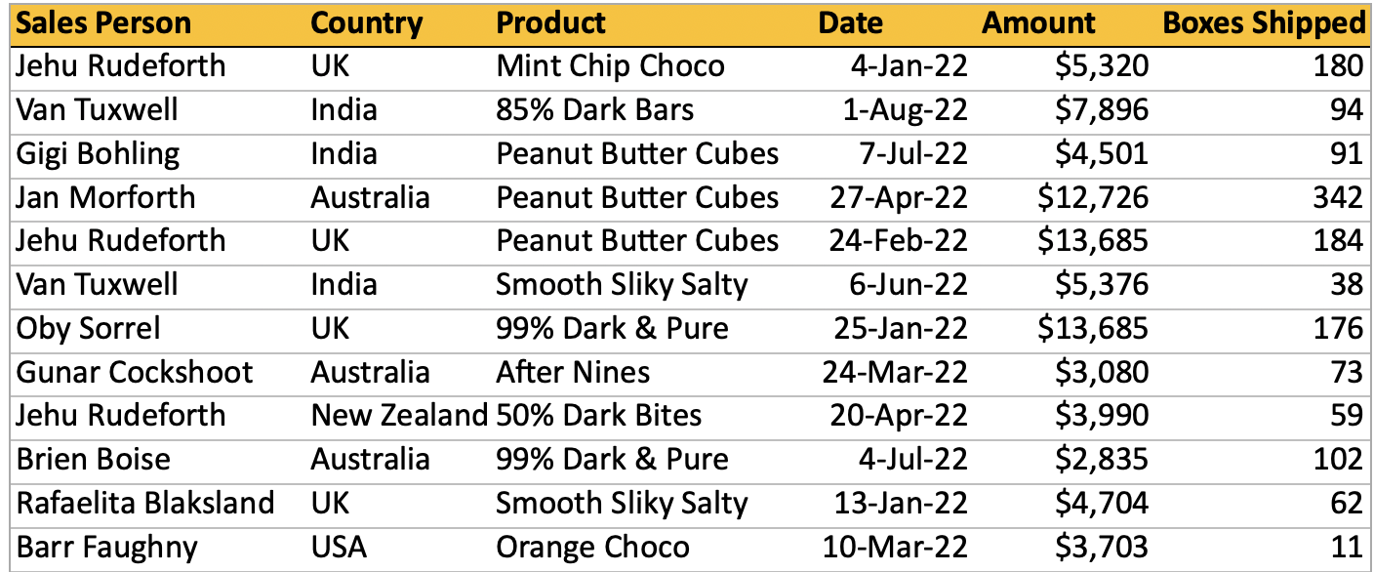

## **2. Dashboard Components**

### **Sheets and Visualizations Created**

1. **Sales by Country**
   1. A bar chart displaying total sales per country.
   2. Helps understand regional demand and identify high-revenue countries.
2. **Top 10 Salespersons by Region**
   1. A ranking table showcasing the top 10 performing salespersons for each country.
   2. Helps in recognizing key contributors to revenue.
3. **Total Sales in USD ($) and Boxes Shipped**
   1. A KPI visualization to track overall business performance.
   2. Displays **total revenue** and **total boxes shipped** in a summarized format.

## **3. Insights and Findings**

* **India and the UK** are key markets for chocolate sales.
* **85% Dark Bars and Mint Chip Choco** are among the best-selling products.
* Salespersons like **Van Tuxwell and Jehu Rudeforth** contributed significantly to total revenue.
* The correlation between **Boxes Shipped and Revenue** suggests product pricing differences.

## **4. Conclusion and Future Scope**

The **Chocolate Business Summary Dashboard** effectively provides insights into sales trends. Future improvements can include:

* Adding **time-series analysis** for trend prediction.
* **Customer segmentation** to understand buyer preferences.
* **Profit margin analysis** to optimize pricing strategies.

🔗 **Dashboard Link:** [Chocolate Business Summary Tableau Dashboard](https://public.tableau.com/app/profile/rohan.k7447/viz/ChocolateBuisnessSummary/Dashboard1?publish=yes)